mRo Quad Zero – Phase 1 Report

# Objective

To simulate the behavior of a palm-sized autonomous drone navigating an indoor maze using a Finite State Machine (FSM) and simulated sensors.

# FSM Design

The FSM includes states: START, FORWARD_SCAN, SIDESTEP, DRIFT_HOLD, GOAL_FOUND, and LAND. Transitions are triggered by simulated wall distance, drift, optical glare, or goal detection.

# Sensor Simulation

• Wall distance (ToF) randomly set between 10–100 cm  
• Drift randomly between 0–20 cm  
• Goal detection randomly triggered  
• Optical glare emulated with random probability

# Visualization and Logging

A Tkinter GUI displays live drone states and sensor values. A Jupyter Notebook plots drift over time using matplotlib. Logs are saved in fsm_log.txt.

# Screenshots

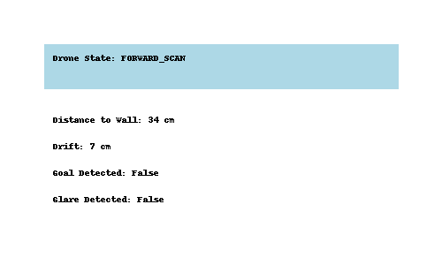

Figure 1: Tkinter GUI Showing Current State and Sensors

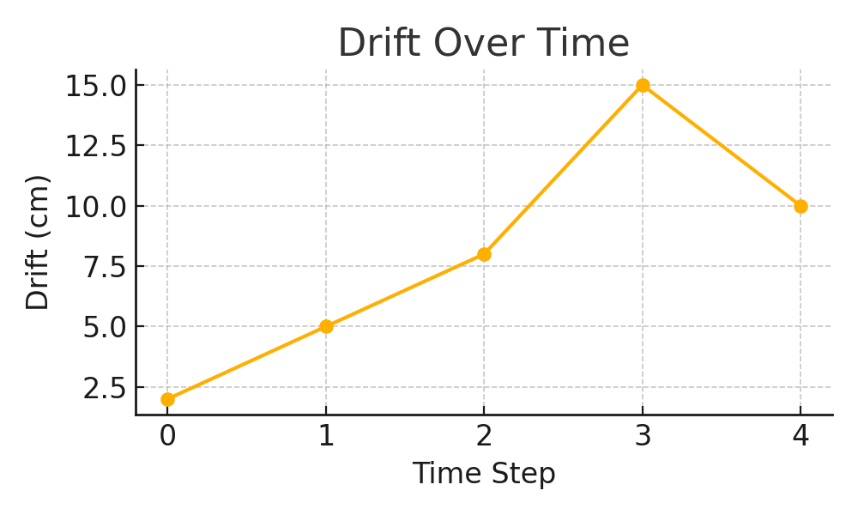

Figure 2: Live Drift Plot

# Conclusion

All objectives for Phase 1 have been completed successfully. FSM behavior, sensor emulation, fault detection, GUI visualization, and logging were implemented and tested in simulation.